Histopathology of SCC

**Tissue of origin**

-Squamous cell carcinoma is a malignant epithelial tumor which originates in epidermis.

-Tumor cells destroy the basement membrane and form sheets or compact masses which invade the subjacent connective tissue (dermis).

- Tumor cells show signs of epithelial dysplasia.

-Tumor cells may surround and destroy blood vessels, and may invade the lumina of vein or lymphatics.

- In well differentiated carcinomas, tumor cells are pleomorphic/atypical, but resembling normal keratinocytes from prickle layer (large, polygonal, with abundant eosinophilic (pink) cytoplasm and central nucleus). Their disposal tends to be similar to that of normal epidermis: immature/basal cells at the periphery, becoming more mature to the centre of the tumor masses. Tumor cells transform into keratinized squames and form round nodules with concentric, laminated layers, called "cell nests" or "epithelial/keratinous pearls". The surrounding stroma is reduced and contains inflammatory infiltrate (lymphocytes).

-Poorly differentiated squamous carcinomas contain more pleomorphic cells and no keratinization. (H&E, ob. x10)

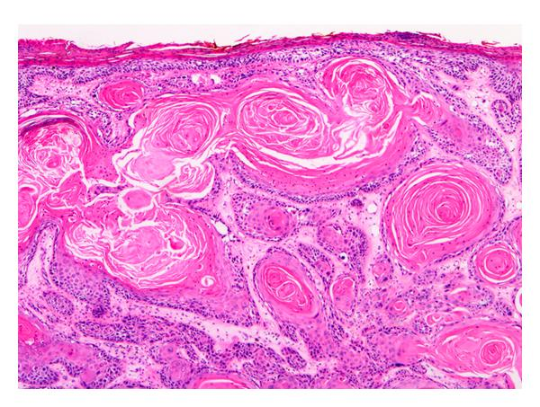

Well-differentiated lesions show prominent keratinization and may form “pearl-like” structures where dermal nests of keratinocytes attempt to mature in a layered fashion (40x).

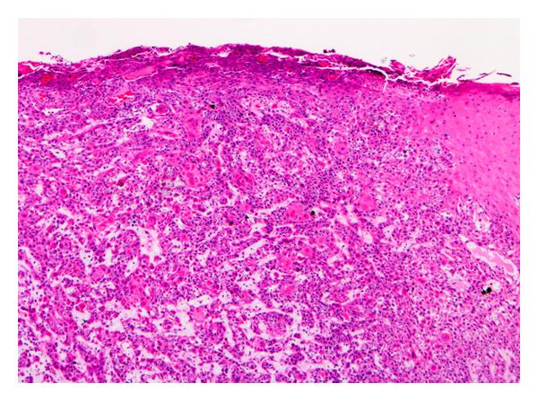

Moderately differentiated lesions of SCCI show much less organization and maturation with significantly less keratin formation (40x).

. **Grading**

* Often graded somewhat subjectively based on degree of differentiation and keratinization: well, moderate, poorly differentiated
* **Well differentiated:** abundant pink cytoplasm, mild to moderate atypia, well developed keratinization
* **Moderately differentiated:** focal keratinization; features between well and poorly differentiated
* **Poorly differentiated:** no / minimal keratinization, high nuclear to cytoplasmic ratio, nuclei are markedly atypical or frankly anaplastic
* **Undifferentiated:** tumors presumed to be SCC based on prior biopsy at same site, but no keratinization identified by light microscopy; immunohistochemistry is usually necessary to exclude melanoma or sarcoma

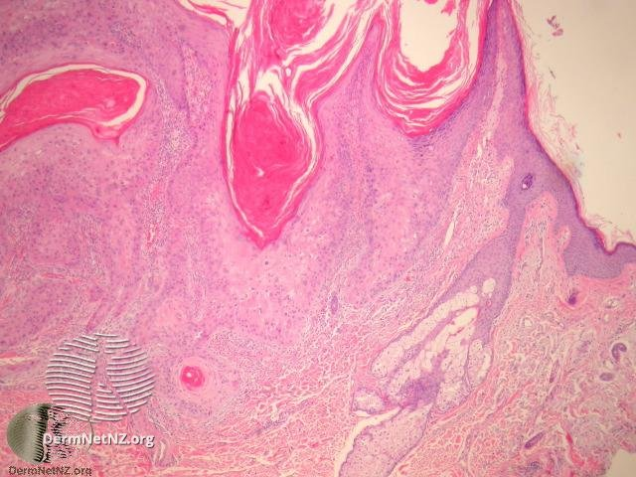 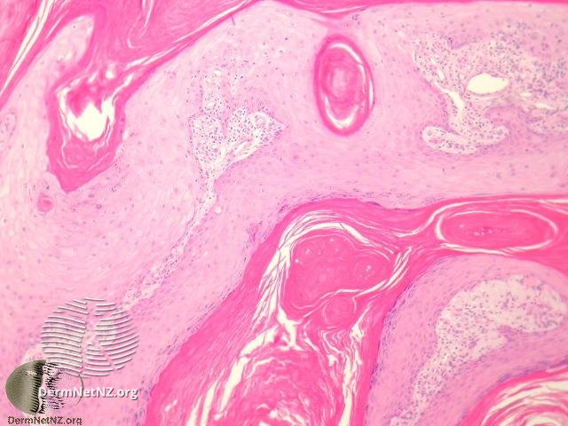

**Well differentiated SCC**

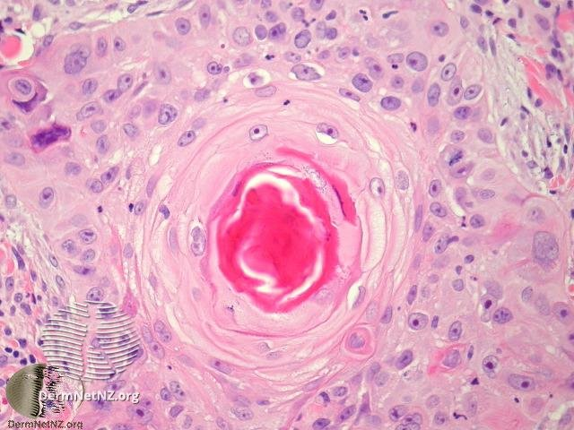 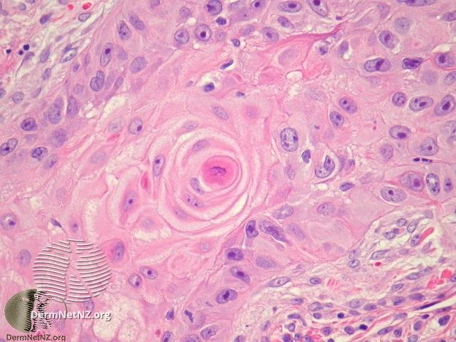

Moderately differentiated SCC

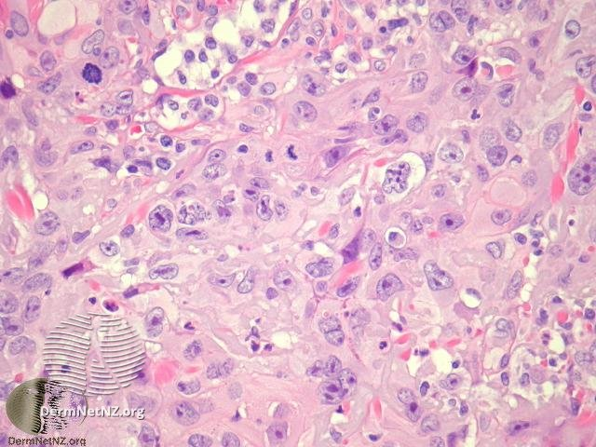

Poorly differentiated SCC

**Tumor Grading**

**Histopathological Grading Systems for Oral Squamous Cell Carcinoma:**

**1. BRODER’S SYSTEM (1927)**

**2. ANNEROTH ET AL (1987)**

**3. BRYNE’S INVASIVE FRONT GRADING (1989, 1992)**

**4. JAKOBBSON ET AL (1973)**

**5. FISHER (1975)**

**6. LUND ET AL (1975)**

**7. WILLEN ET AL (1975)**

**8. CRISSMAN ET AL (1980)**

**1.Broder’s (1920) classification:**

Accordingly, tumors were graded on the basis of degree of differentiation and keratinization of tumor cells into

Grade I: Well differentiated tumors – 75-100% of cells are differentiated

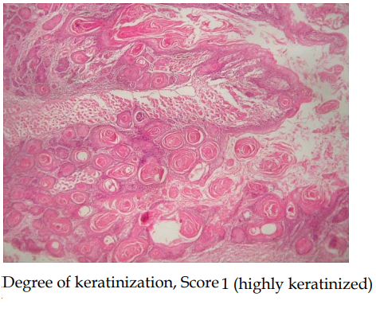

Grade II: Moderately differentiated tumors – 50- 75% of cells are differentiated



Grade III: Poorly differentiated tumors – 25-50% of cells are differentiated

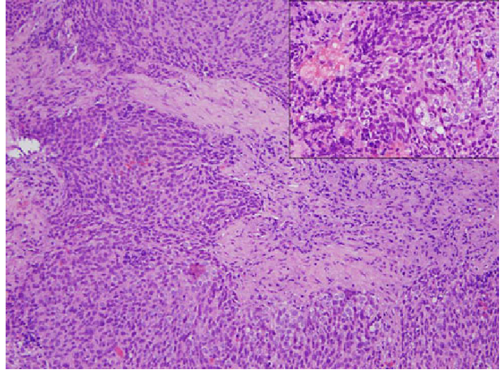

Grade IV: Anaplastic tumor – 0-25% of cells are differentiated

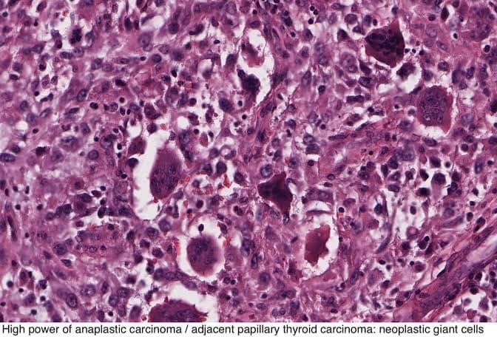

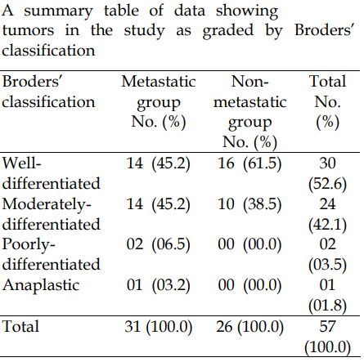

**2. Anneroth’s et al (1987) multifactorial grading system:** According to this system, three parameters reflecting tumor cell features including keratinization, nuclear pleomorphism, and mitoses were evaluated in the whole thickness of the tumor and each scored from 1-4. Pattern of invasion, stage of invasion, and lymphoplasmacytic infiltration representing tumor-host relationship were graded in the most invasive margins and scored from 1-4. Then the sum of scores were grouped as follows: 6-12 grade I, 13-18 grade II, 19-24 grade III, and the results were compared in the metastasizing and non-metastasizing groups.

 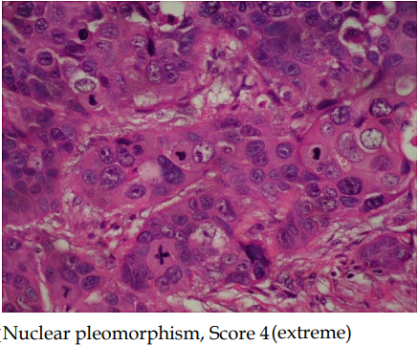

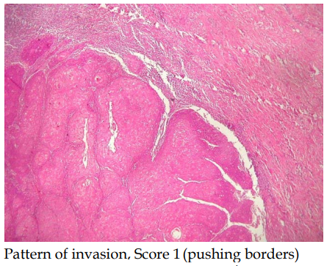 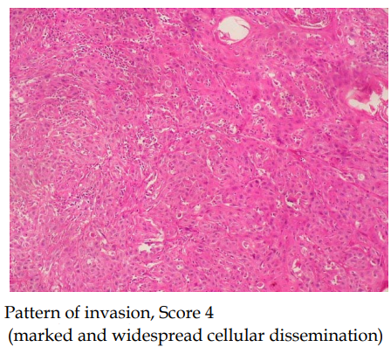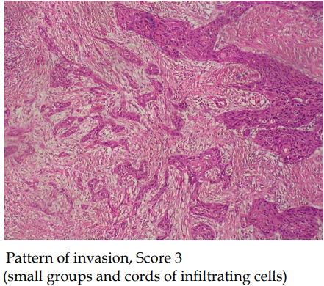 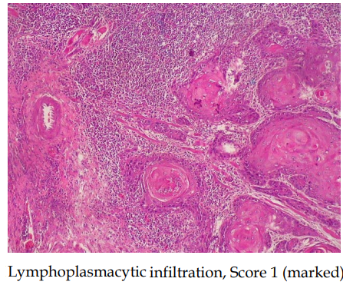

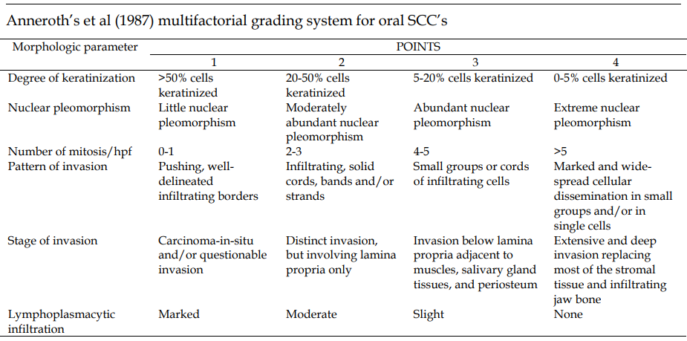

**3. Bryne’s et al (1992) deep invasive cell grading system:** According to this system, number of mitosis and stage of invasion was omitted from the Anneroth’s grading system, while the rest of the 4 parameters mentioned above were measured in the deepest invasive margins, and not in the whole thickness of the tumor, and graded similarly. The sum of scores were grouped as follows: 4-8 grade I, 9-12 grade II, 13-16 grade III, and the results were compared in the metastasizing and non-metastasizing groups. In cases where opinion of the two authors differed, the disagreement was resolved by consensus after joint review using a multiheaded microscope, and reviewed by the third author. The results of the three grading systems in each of the two groups (metastatic and non-metastatic) were analyzed by logistic regression.

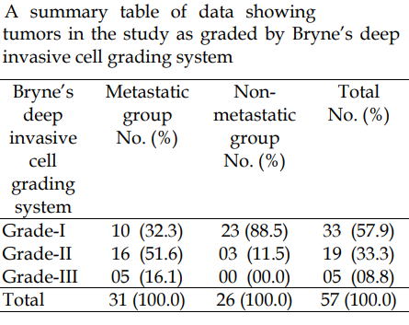

4. JAKOBBSON ET AL. (1973):

This system not only includes the morphologic parameters “structure”, “tendency to keratinization”, “nuclear aberrations”, and “number of mitosis”, but also an evaluation of tumor-host relationship as estimated by parameters such as “mode,” “stage of invasion”, “vascular invasion” and “degree of lymphoplasmocytic infiltration”

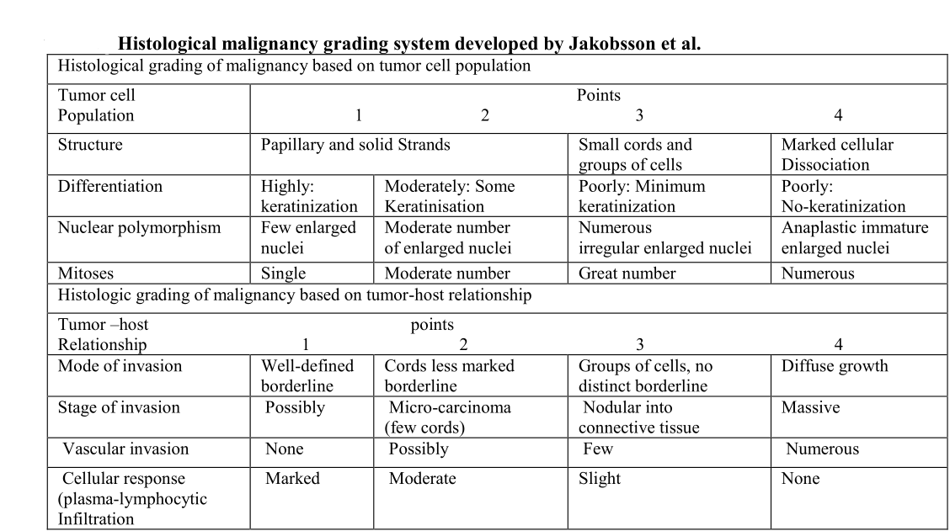

5. FISHER (1975)

They modified slightly, the grading system developed by Jakobsson et al. and indicated the malignancy grade of biopsy tissue tended to be lower than the grade of definitive section obtained from surgical specimen.

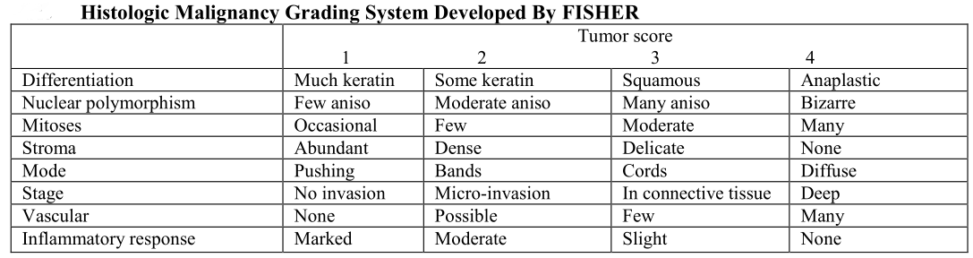

6. LUND et al (1975)

They also modified, grading system of Jakobsson et al. by presenting a more exact definition of each parameter and grade and by introducing a histologic score, defined a total sum of points divided by the number of parameters evaluated. They found a statistically significant correlation between microscopic score and death rate as well as the frequency of local recurrence and regional lymph node metastases in a series of 438 patients with squamous cell carcinoma of the tongue.

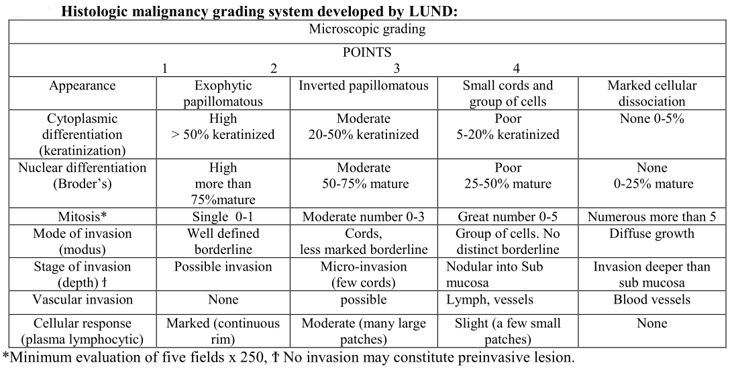

7. WILLEN et al (1975)

They also used modified system of Jakobsson et al. They consisted of the deletion of two morphological parameter “structure” and “vascular invasion”. The results showed no definitive correlation between the clinical stage and histologic grading of malignancy. In the group with no metastases the neoplasm were highly differentiated and mitotic rates were low, but nuclear polymorphism was sometime prominent. In the group with metastases the neoplasm were less differentiated and advanced nuclear aberrations with increase mitotic rates.

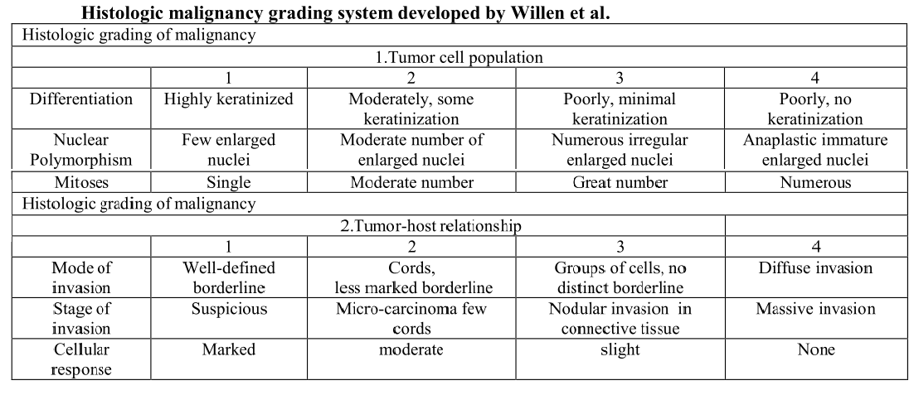

8. CRISSMAN e They modified the criteria outlined by Jakobsson et al. in two steps. They included a different point scale for vascular invasion and structure and mode of invasion into a single parameter “pattern of invasion”. The new parameter was considered to reflect the capacity of the tumor cells cohesiveness to keep the tumor cell population together as well as the association of the invading tumor cell and host stroma. “Differentiated” cohesive neoplasm infiltrated with well delineated pushing margins, whereas “less differentiated” non-cohesive neoplasm infiltrated as small, irregular neoplastic cell aggregates or single cells. This modified system applied on 73 oral squamous cell carcinoma patients. This result shows only the “frequency of mitosis.”t al (1980)

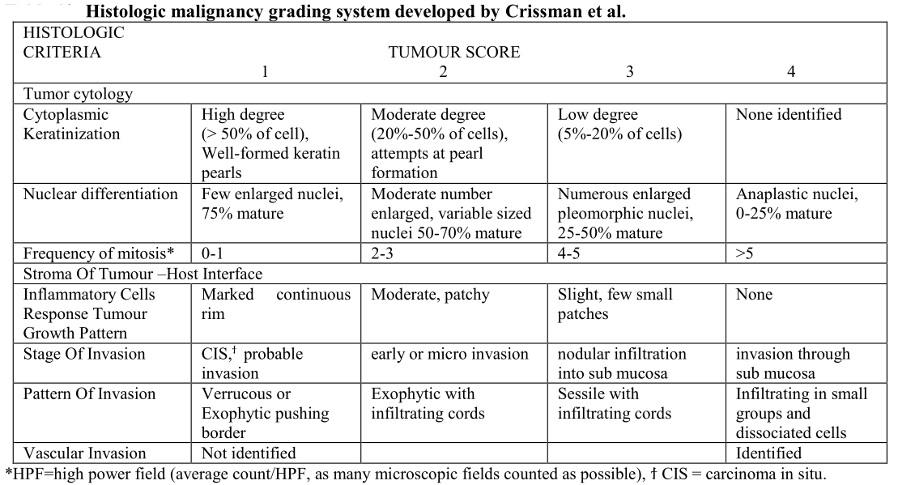

**CONCLUSION**

A significant percentage of patients with early stages of SCC have a poor prognosis despite the small size of the tumor. Hence TNM staging system used in clinical practice does not provide information on the biological characteristic and aggressive clinical behavior of oral SCC. The first and most widely practiced grading system for oral SCC was developed by AC Broder. Since then a multitude of multifactorial grading systems have developed. Jacobsson and Anneroth grading system, are still sometimes used and studied. However, the most recent of these multifactorial grading systems developed by Bryne et al (1992), which analyses four factors of the carcinoma in its invasive front is most reproducible but less popularly used. We found a significant positive trend between Bryne’s deep invasive cell grading system with lymph node metastasis; while all the other grading systems, especially the most popularly used Broder’s classification failed to show any statistical significance to lymph node metastasis. In conclusion, we believe that Bryne’s grading of the invasive parts of oral SCC could be taken as a valuable predictive factor in lymph node metastasis. The clinical value of this system can be increased if larger pieces of biopsies are taken from the tumor. Generally, in the oral cavity, there are no contraindications for the removal of biopsies measuring 15´ 5´ 5 mm from representative areas. In most cases, this would be sufficient for invasive cell grading. There could be scope of further improving the clinical value of this histological grading system by including new immunohistochemical markers like expression of vascular endothelial growth factor-C (VEGF-C) and Ki-67 that take into account the biological behavior of the tumor.

**Variants of SCC**

Conventional SCC and variants of OSCC frequently arise within the oral cavity. Precise histopathological diagnosis can help the clinician to plan accurate treatment, as the prognosis of each of them differs considerably.

**1-Conventional Squamous Cell Carcinoma**

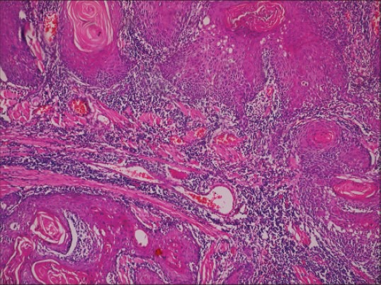

**Conventional oral squamous cell carcinoma-malignant epithelial islands showing keratin pearl formation. (H&E stain, ×100)**

**2- Verrucous Carcinoma**

VC is a very well-differentiated SCC that does not metastasize and has an excellent prognosis with 5-year survival rate of approximately 75%. The lesion has a possibility of metastasis only if it is left long enough and allowed to become more invasive

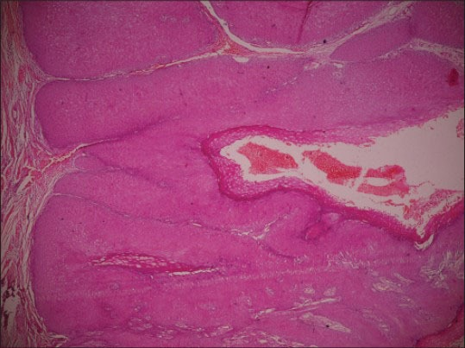

Verrucous carcinoma-broad bulbous pushing rete ridges with parakeratotic plugging (H&E stain, ×100)

**3- Adenoid squamous cell carcinoma**

AdSCC occurs in the oral cavity infrequently as they usually affect sun-exposed areas with vermillion border of the lip being the most commonly affected site. They have a relative poorer prognosis as compared with conventional SCC.

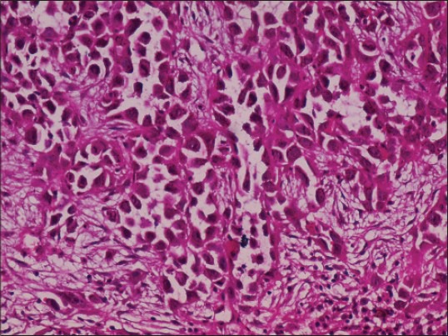

Adenoid squamous cell carcinoma -pseudoglandular pattern with acantholytic tumor cells. (H&E stain, ×200)

**4- Spindle cell carcinoma**

SCSC metastasizes to the regional lymph nodes in upto 25% cases, but distant metastasis is less common (5-15%). The 5-year survival rate varies between 65-95%

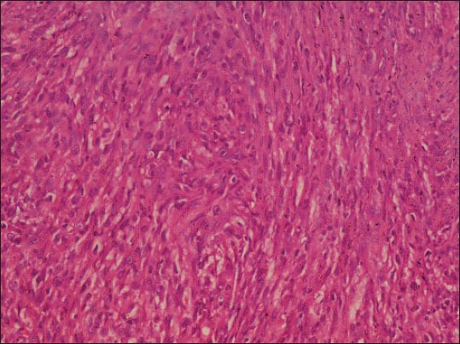

Spindle cell carcinoma-malignant epithelial cells showing spindling/sarcomatoid appearance (H&E stain, ×100)

**5-Adenosquamous carcinoma**

ASC has an aggressive behavior, poorer prognosis and a propensity for locoregional and distant metastasis, especially to the lungs. Larynx is most commonly affected (70%) followed by the oral cavity (30%). It shows approximately 2-year survival rate of approximately 55%

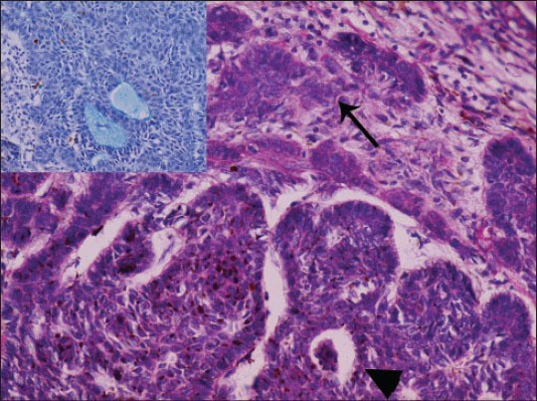

Adenosquamous carcinoma-biphasic tumor showing true glandular differentiation (arrowhead) along with squamous differentiation (arrow) (H&E stain, ×100). Inset depicts alcian bluepositive mucin secretion (×400)

**6-Basaloid squamous cell carcinoma**

BSCC is regarded as a high-grade tumor with an increased propensity for distant metastasis. It requires aggressive multimodality treatment. The 2-year survival rate is 40%. BSCC more frequently affects the larynx. It has a better prognosis when compared with location and stage-matched conventional OSCC.

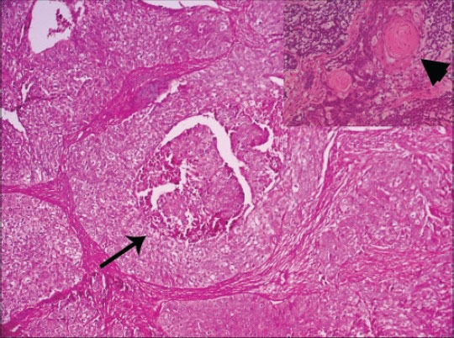

Basaloid squamous cell carcinoma biphasic tumor showing basaloid malignant islands with peripheral palisading and comedonecrosis (arrow) (H&E stain, ×100). Inset depicts squamous differentiation with keratin pearl formation (arrowhead) (H&E stain, ×100)

The International Classification of Diseases for Oncology (ICD-O) system lists a number of morphological subtypes and variants of malignant squamous cell neoplasms, including:

Papillary thyroid carcinoma

Verrucous squamous cell carcinoma

Papillary squamous cell carcinoma

Squamous cell carcinoma

Large-cell keratinizing squamous cell carcinoma

Large-cell nonkeratinizing squamous cell carcinoma

Small-cell keratinizing squamous cell carcinoma

Spindle-cell squamous cell carcinoma

Adenoid/pseudoglandular squamous cell carcinoma

Intraepidermal squamous cell carcinoma

Lymphoepithelial carcinoma